Republic Da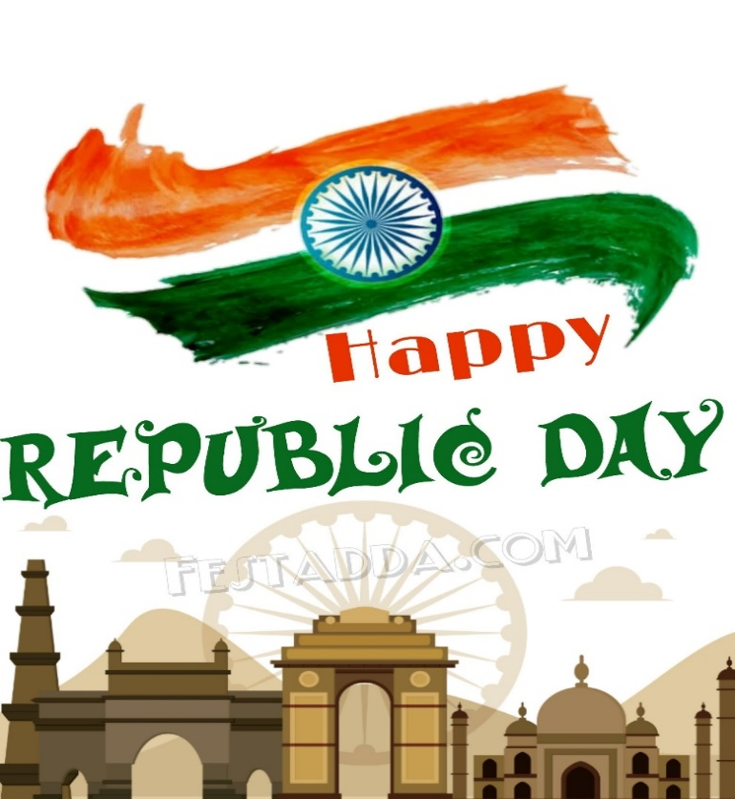y

* Republic Day, celebrated every year on 26th January has a special significance in the history of India.
* To make the event memorable the national event is celebrated every year with a lot of joy, happiness, and pride in our hearts.